Convert svg to 1.0

*** Please using AI to convert file
- Open svg file using AI
- Select object
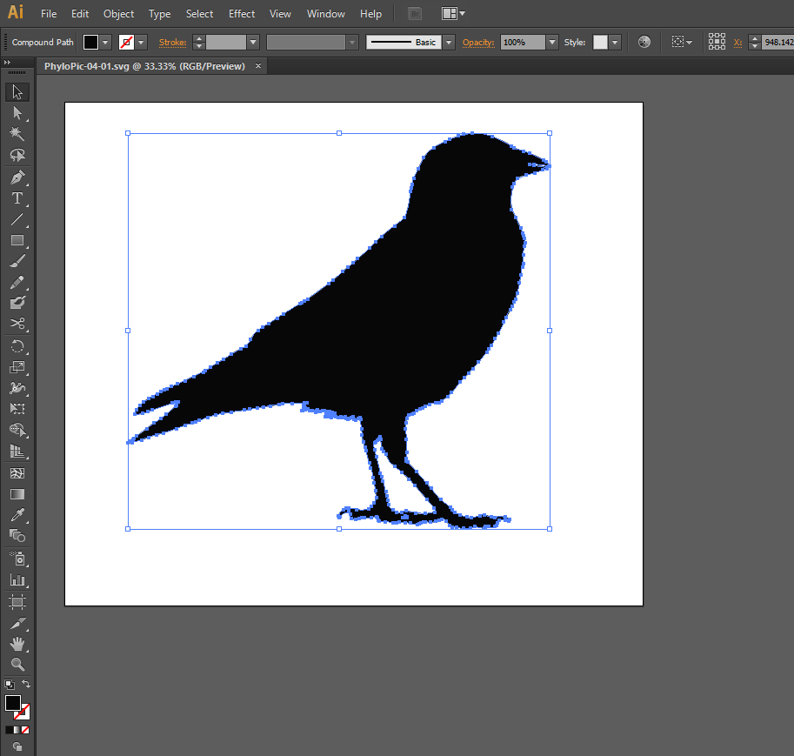

- Change fill color of object

- Change fill color to any except black. ( Because black will not be count a color when render)
- 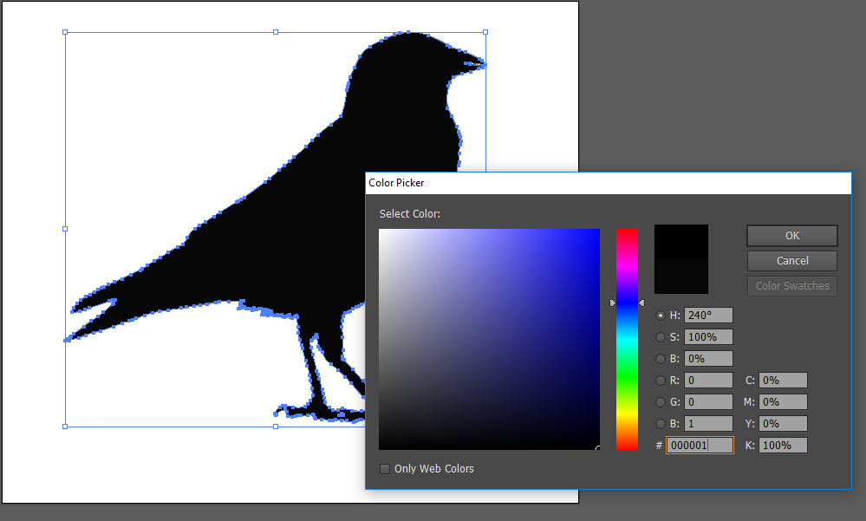

*** Save as this file to svg
Please select use Artboards function to enter modify save file SVG option
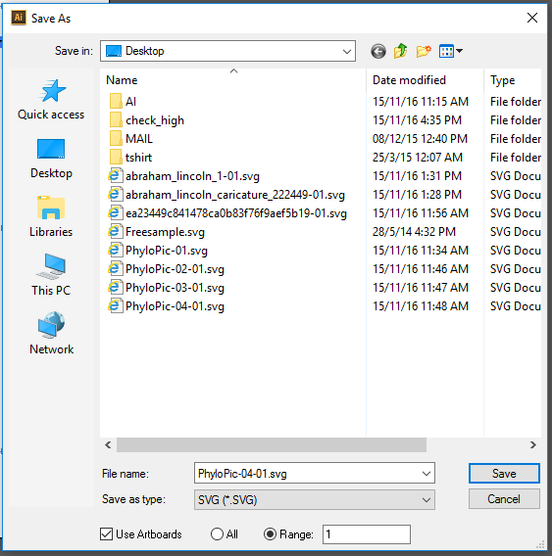

Please select all option like my select. And press OK to apply this option
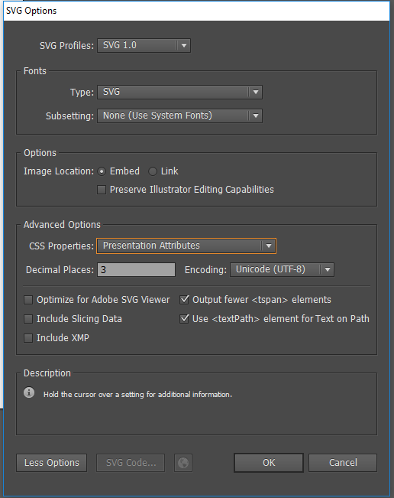

After convert the SVG file. Please upload and test new file on our admin tool.
Thanks

